redirect http(s) Webrequest to https Server

**create App Service Plan**

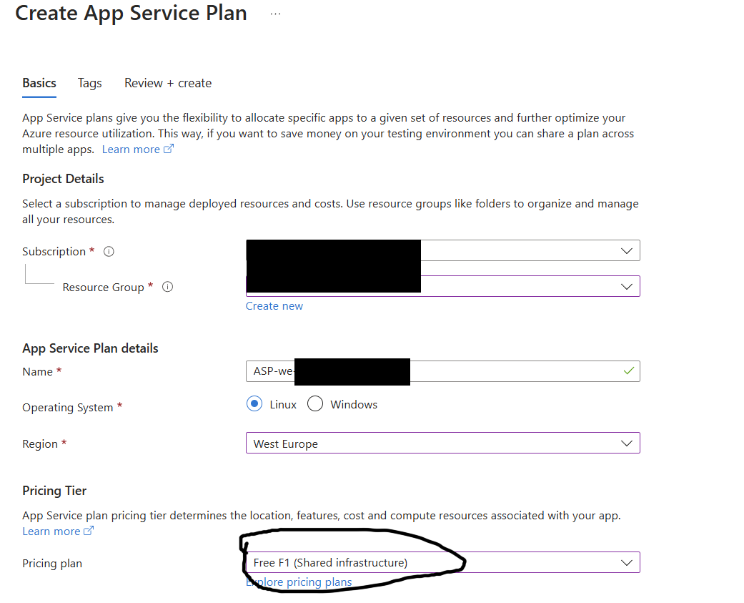

**Install Azure Static Web Apps extension in VS Code  
  
**

**In VS Code we must use a Repo.   
I think it has to be Github. So that the assistant can create it, I opened a local repository with an empty folder beforehand*. People with knowledge of VS Code or software development would probably work differently...**

**\*  
Open Folder  
Strg+Shift+G  
create a File in Repo (explorer new File ->)   
  
Main (Ctrl+Enter)**

**Create static Web Apps in VS Code  
**

**Config via VS Code**



**Use HTML als Framwork  
/ and empty as location**

**Create a empty index.html and staticwebapp.config.json with the magic in Github (Online, via VS Code,…) :  
  
{**

**"routes": [**

**{**

**"route": "/*",**

**"redirect": "https://tenantnameasexample.sharepoint.com/sites/intranet",**

**"statusCode": 301**

**}**

**]**

**}**

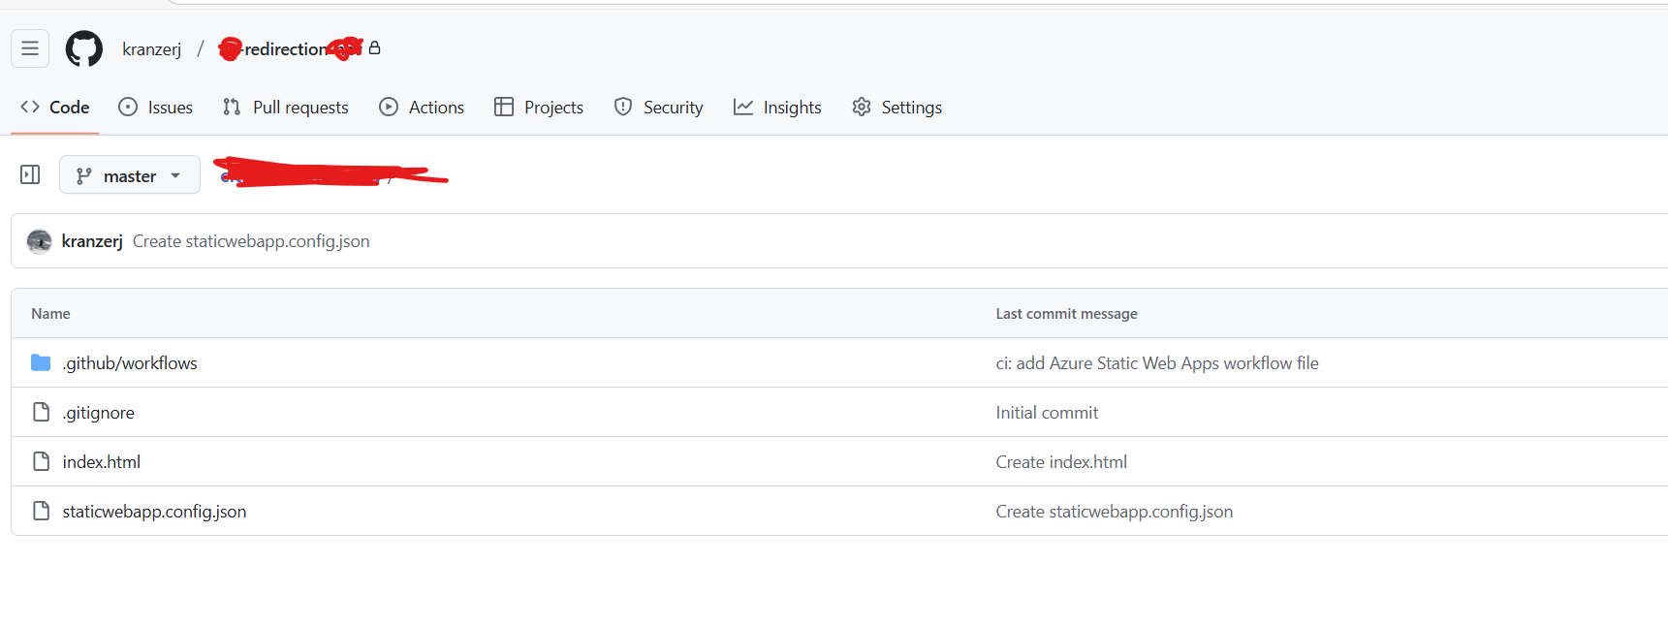

**Sync Data to Azure**

**Config Custom Domain in Static Web App**

**For subdomains (third-level domains), a CNAME is usually the best option. For second-level domains, an A record is recommended. That should cover everything.**